- General Risk Assessment
Participant Details
Participant Frist Name |  | Participant Last Name
Date of Birth | Day____/Month___/Year_____ | Preferred contact  Method | Phone  Email
Contact Number |  | Email Address

Participant Requirements / Preferences
Specific requirements and  preferences: | Communication Needs Hearing Needs  Beliefs such as religious or cultural

Known Medical Conditions or Allergies
Condition and/or Allergies | Effect | Treatment

Persons Involved in Risk Assessment
Was the participant involved in the assessment? | Yes
Was the participant involved in the assessment? | Declined | Reason:
Was the participant involved in the assessment? | Unable | Reason:
Staff Involved Name:
Others Involved Name:

Participant’s Emergency Contact Details (Next to Kin)
Name
Mobile
Email
Participant’s Emergency Contact Details (Secondary)
Name
Mobile
Email

- OH&S Risk Assessments
No. | Item | Yes | No | Comments
1 | Is this person known to the service?
2 | Have they consented to the proposed visit?
3 | Is the client or others known to be potentially aggressive, violent or disturbed?
4 | Is there evidence that the client or others at the premises may be under the influence of alcohol or drugs?
5 | Is the service to be provided at night or outside of normal working hours?
6 | Has relevant medical history been communicated including potential risk situations?
7 | Is there a risk of the client or others at this premises using a weapon?
8 | Does the client have any pets? If yes, will they be securely locked away during the visit?
9 | Are there additional people expected to be present at the time of the visit?
10 | Is the client/carers aware of the proposed visit?
11 | Has the client/carers consented to the proposed visit?
12 | Are the premises easily accessible from the street?
13 | Are there any expressive language concerns?
14 | Does the participant have any road safety skills?
15 | Is there a history of any family members with behavioural issues?
16 | Does this participant pose a risk to themselves or others?

- COMMUNICATION WITH OTHER PROVIDERS
Information Sharing and Privacy
Ensure that the Privacy Policy has been explained and the participant has consented to share information (Form18 Participant Information Consent Form; page 2). Based on the participants support networks, please indicate below providers for services being used and if they want to share their information with them.
Provider 1
Provider Name |  | Key Contact Name
Key Contact Phone |  | Key contact email
Frequency of  Contact |  | Method of Contact:
Provider 2
Provider Name |  | Key Contact Name
Key Contact Phone |  | Key contact email
Frequency of  Contact |  | Method of Contact:

- MEDICATION
Management of Medication
Should any of the below be marked as YES, refer to Form 24. Management of Medication
Assistance of Medication Required | YES NO
Prompt Medication Required | YES NO
Administration of Medication Required | YES NO
NO – This participant does not require medication management

- EMERGENCY PREPARATION
5.1. The first step in being prepared is to have a Participant emergency and evacuation plan. Complete the following emergency and evacuation plan so that everyone in the Participant’s support network knows exactly what to do if the worst happens.
The plan includes measures for each of the following:
- preparing for, and responding to, the emergency or disaster;
- making changes to participant supports;
- adapting, and rapidly responding, to changes to participant supports and to other interruptions;
- communicating changes to participant support to workers, participants and their support networks.
Emergency Contact Numbers
Police |  | 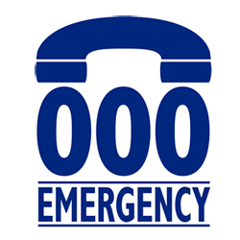
Fire
Ambulance
Key Personnel (24 Hours Contact)
Personnel Type | Name |  | Contact Number
Fire Warden
First Aider

Participants who require special assistance
Assistance required
Aids required (if applicable) (wheelchair, pets, food)

Utility companies' contact details
Type | GAS | Type | WATER
Provider |  | Provider
Phone |  | Phone
Type | ELECTRICITY | Type | OTHER
Provider |  | Provider
Phone |  | Phone

  - Type of support to be put in place in the event of an Emergency or Disaster and how we will support the participant such as the respiratory depression (based on the Service agreement)
Emergency | Support provided to the participants DURING an emergency | Support provided to the participants AFTER an emergency

Participant Household Safe Meeting Point
Address
Description

Emergency And Evacuation Kit Location
Location

- MODE OF COMMUNICATION

Style of Communication | Details and Aids used (if applicable)
Verbal
Non-verbal/vocalise
Sign language
Auslan
Key Word Sign
Point/gesture
Other - please specify:

- Participant Dependency and Health-Safety Risk Assessment Table
Steps to Use the Extended Table:
- Assessment: Evaluate both the level of reliance on your services and the potential impact on health and safety for each participant.
- Categorisation: Assign the appropriate risk level based on the combined assessment of reliance and health-safety impact.
- Mitigation: Develop strategies and contingency plans that address not only the level of reliance but also the specific health and safety concerns identified for each risk level.
- Regular Review: Continuously review and update the risk assessment and mitigation strategies, considering any changes in participants' needs and potential risks.
- Communication: Ensure that all stakeholders, including participants, families, and your team, understand the dual assessment of reliance and health-safety impact, as well as the corresponding mitigation plans.
- Emergency Planning: For participants with higher risk levels, develop emergency plans that outline steps to be taken in case of service disruptions or unexpected events.
By considering both the participants' level of reliance on the services and the potential consequences for their health and safety in case of disruptions, we can create a more comprehensive risk assessment framework that prioritises their well-being. Therefore, prioritising the health and safety of participants is a fundamental responsibility that promotes their well-being, respects their rights, and contributes to the overall success and sustainability of various activities and endeavours, and ultimately, the level of support the provider is required to provide the participant during their care.

Risk Level | Description | Criteria | Impact on Health-Safety | Select risk level
Low | Participants have a low reliance on provider services to meet daily living needs. | Participants can independently perform most daily living activities without assistance. Any disruptions in services would have minimal impact on their overall well-being. | Disruptions in services would have minimal impact on participants' health and safety, as they can manage most activities independently.
Moderate | Participants have a moderate reliance on provider services for certain daily living needs. | Participants can perform some daily activities independently but rely on the provider for specific tasks such as transportation, meal preparation, or medication management. A disruption in services could moderately affect their overall well-being. | Disruptions in services could moderately impact participants' health and safety, particularly for tasks they rely on the provider to assist with.
High | Participants have a high reliance on provider services to meet essential daily living needs. | Participants require significant assistance from the provider for activities of daily living, including personal care, mobility, meal preparation, and medication management. A disruption in services would have a significant impact on their overall well-being and quality of life. | Disruptions in services would significantly impact participants' health and safety, as they rely heavily on the provider for essential tasks. There could be risks related to personal care, medical needs, and more.
Critical | Participants have a critical reliance on provider services for all daily living needs. | Participants are entirely dependent on the provider for all activities of daily living, including personal care, mobility, communication, medical support, and more. Any disruption in services would pose a severe and immediate threat to their health and well-being. | Disruptions in services would pose a critical threat to participants' health and safety. Their complete dependency on the provider means that any interruption could lead to life-threatening situations.

- Risk Assessment for Participant
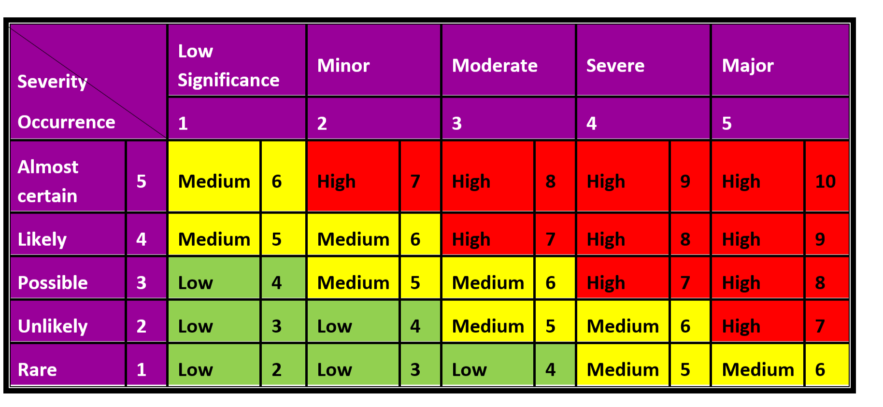
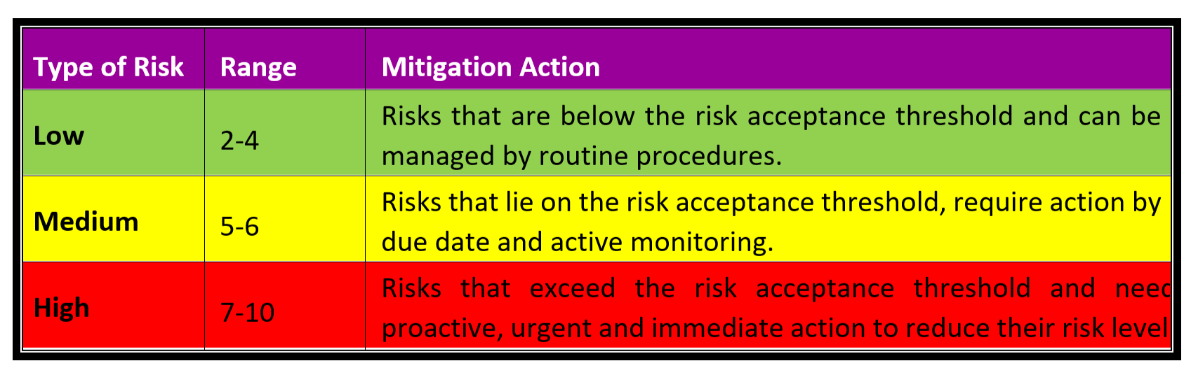
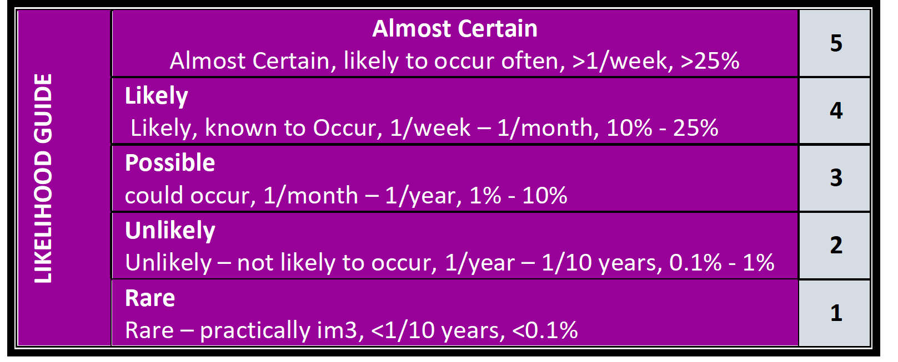

No. | Tasks or Activity | Issue/Hazard/Aspect | Risk/Impact | Consequence | Likelihood | RISK SCORE | Control Measures | Person Responsible | Residual Risks
 |  |  |  |  |  |  |  |  | Consequence | Likelihood | RISK SCORE

- Risk Assessment for participants subject to Section 73 G
(ONLY fill in FROM THIS SECTION ONWARDS UP TO 8.4 if the participant is living alone and supported by a sole support worker at one time)
  - Risk Assessment Detail
Daily Personal Activities – for participants living alone (if yes, please complete monitoring and supervision plan too)
Sole Support Worker | Yes No | Reason: | Participant preference | Other:
Sole Support Worker | (If yes, a Monitoring and Supervision Plan is required)
  - Identify Risks
Risk category | Risk factors |  | Tick all applicable risks
Daily Personal Activities Support - for participants living alone
Personal contact | No regular face-to-face contact with other NDIS providers |  | Yes
Personal contact | Limited or irregular face-to-face contact with relatives, friends or other people |  | Yes
Physical Mobility | Relies on other people to be physically mobile or to facilitate their physical mobility |  | Yes
Physical Mobility | Uses equipment to enable them to be physically mobile or to facilitate their physical mobility. |  | Yes
Communication | Without the assistance of another person the participant has limited or no ability to communicate. (for participants requiring communication support, in case there is an emerging health situation, they should communicate their situation as soon as possible to their support worker and/or their advocate. If answer “YES’ to this question refer to the mode of communication assessment section of this document). |  | Yes
Communication | The participant uses equipment to enable or facilitate communication with others, including to enable or facilitate the use of a phone or other device. |  | Yes
Note: If support will be delivered by the sole support worker, and any of the above risks apply, a Monitoring and Supervision Plan must be created. In the monitoring and supervision plan, emerging health situation and the relevant mode of communication (for non-verbal participants) and the disaster scenarios should be considered.

Risk category |  | Risk factors | Tick all applicable risks
Disruption to services - What would happen to the participant if the provider was unable to provide the support needs for a particular amount of time?
Personal contact |  | Does this participant rely on regular support to have personal contact with other people? | Yes
Health & Safety |  | Does the participant require support to attend to their own personal care? (showering, toileting etc) | Yes
 |  | Does the participant require support be able to prepare and eat food?  \ | Yes
Physical Mobility |  | Does the participant rely on support to be physically mobile or to facilitate their physical mobility? | Yes
 |  | Does the participant rely on support equipment (operated by a support worker) to enable them to be physically mobile or to facilitate their physical mobility? | Yes
Communication |  | Does the participant rely on support workers to assist them to use equipment to enable or facilitate communication with others, including to enable or facilitate the use of a phone or other device? | Yes
Note: Please refer to risk assessment matrix below to indicate what category the participant falls into if their support services were to be disrupted. Depending on the outcome, the provider should refer to Form 01. Risk Register to determine control measures to be taken in such situations.

  - Risk Assessment Matrix
Type of Risk | Risk Category
Either one of Personal Contact, Physical Mobility or Communication Risk | Low Risk
A combination of any 2 types of risk categories | Medium Risk
A combination of all 3 types of risk categories | High Risk

8.3a Monitoring and Supervision Plan
Risk Monitoring and Supervision - Participants Living Alone - Sole Support Worker
Participant Risk* |  |  | Monitoring Types and Frequencies
Identified Risk | Comment | Risk  Level | Communication with participant |  |  | Worker  Reports | On-site  Monitoring | On-site  Supervision | Other  Supervision*
Identified Risk | Comment | Risk  Level | Feedback | In-person | Other  (specify)
E.g.: Infection | Has history of  infections | High | Quarterly  survey | 6 monthly | phone  monthly | Twice weekly -  Mon & Thurs | Every 2  Months | 6 monthly | Fortnightly  by phone
E.g. Needs  assistance with mobility | May be unable to return to chair/  access mobility | Low | as above | as above | as above | Report  incidents | as above | as above | as above

8.3b Daily Personal Activities- Support Worker
SUPPORT WORKER DETAILS - Complete where services provided by the sole support worker
Family name |  |  |  |  | Mobile Phone
Given names |  |  |  |  | Email address
SELECTION CRITERIA
Participant Requirements / Preferences (Male / Female support worker)
Worker Suitability
Mandatory NDIS Worker Orientation Module  worker  Yes |  |  |  |  | NDIS Worker Screening Check / National Police Check worker
100 point ID |  |  |  |  | Other Documents:
Worker Competencies
Relevant qualifications |  |  |  |  | Feedback process
Specify: |  |  |  |  | Reporting process
Relevant experience ☐ |  |  |  |  | Incident reporting process
Specify: |  |  |  |  | Can identify and respond to all risks identified  above ☐
Meets the communication requirements (eg, Sign language etc.)

8.4. Authorisation
Authorised by |  | Role
Signed |  | Date | Day______/Month______/Year_______
Participant/Guardian Signature |  | Date | Day______/Month______/Year_______
Is a copy of this form provided to the participant? | Yes  No
Is a copy of this form placed in the Participant’s file? | Yes
Date for Review | Day_______/Month_______/Year_______

__ _ _ __ _ _ _ __ _ _ _ __ _ _ _ __ _ _ _ __ _ OFFICE USE ONLY_ _ _ _ __ _ _ _ __ _ _ _ __ _ _ _ __ _ _
Person completed Name:
Person completed Signature:
Date | Day_______/Month_______/Year_______
Date for Review: | Day_______/Month_______/Year_______

